You will be creating a menu app using Angular.

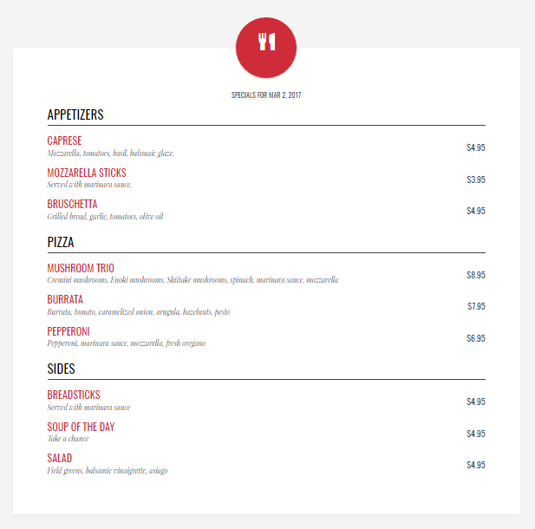

Complete the following steps:

1. Open the **app.js** file and create a new module named ***MenuApp***.
2. Open the **index.html** file and attach the module to the <body>element.
3. Open the **MainController.js** file. Notice the **$scope.appetizers** property containing an array of two objects. Add a third object to this array with the following values:
   1. Name: Bruschetta
   2. Description: Grilled bread, garlic, tomatoes, olive oil
   3. Price: 4.95
4. Attach the controller to the <div> element with the class “main”.
5. Find the <div> element with the class “appetizer row”. Add the *ng-repeat* directive to loop through the appetizers array. Display each appetizer’s name, description, and price using expressions. Use the currency filer to format the price.
6. In your controller, add another property called **$scope.mains**, containing an array of three objects. Add three dishes of your choice.
7. Using the <div class=”appetizer row”> as a guide, create a div with the class of “mains row”. Use the ng-repeat directive to loop through the mains array and display each item using expressions and the currency filter.
8. In your controller, add another property called **$scope.sides**, containing an array of three objects. Add three side dishes of your choice.
9. Similarly to the previous steps, loop through the extras array and display each item.